8.Describe major services (functionality) provided by a hospital's reception.
Summary: Hospital Management System is a large system including several
subsystems or modules providing variety of functions. Hospital Reception subsystem
or module supports some of the many job duties of hospital receptionist. Receptionist
schedules patient's appointments and admission to the hospital, collects information
from patient upon patient's arrival and/or by phone.
For the patient that will stay in the hospital ("inpatient") she or he should have a bed
allotted in a ward. Receptionists might also receive patient's payments, record them in
a database and provide receipts, file insurance claims and medical reports.

AIM:

To describe the major services (functionalities) provided by a hospital's reception.

PROCEDURE:

Identify Key Functions:
- Appointment Scheduling:
  - Schedule patient appointments.
  - Manage patient admissions.
- Patient Information Management:
  - Collect and store patient details.
  - Maintain contact and medical records.
- Billing and Payment Processing:
  - Process patient payments.
  - Generate and provide receipts.
- Insurance and Medical Reports:
  - File insurance claims.
  - Manage and update medical reports.
Bed Allocation for Inpatients:
- Assign hospital beds.
- Manage patient stay duration.

DIAGRAM:

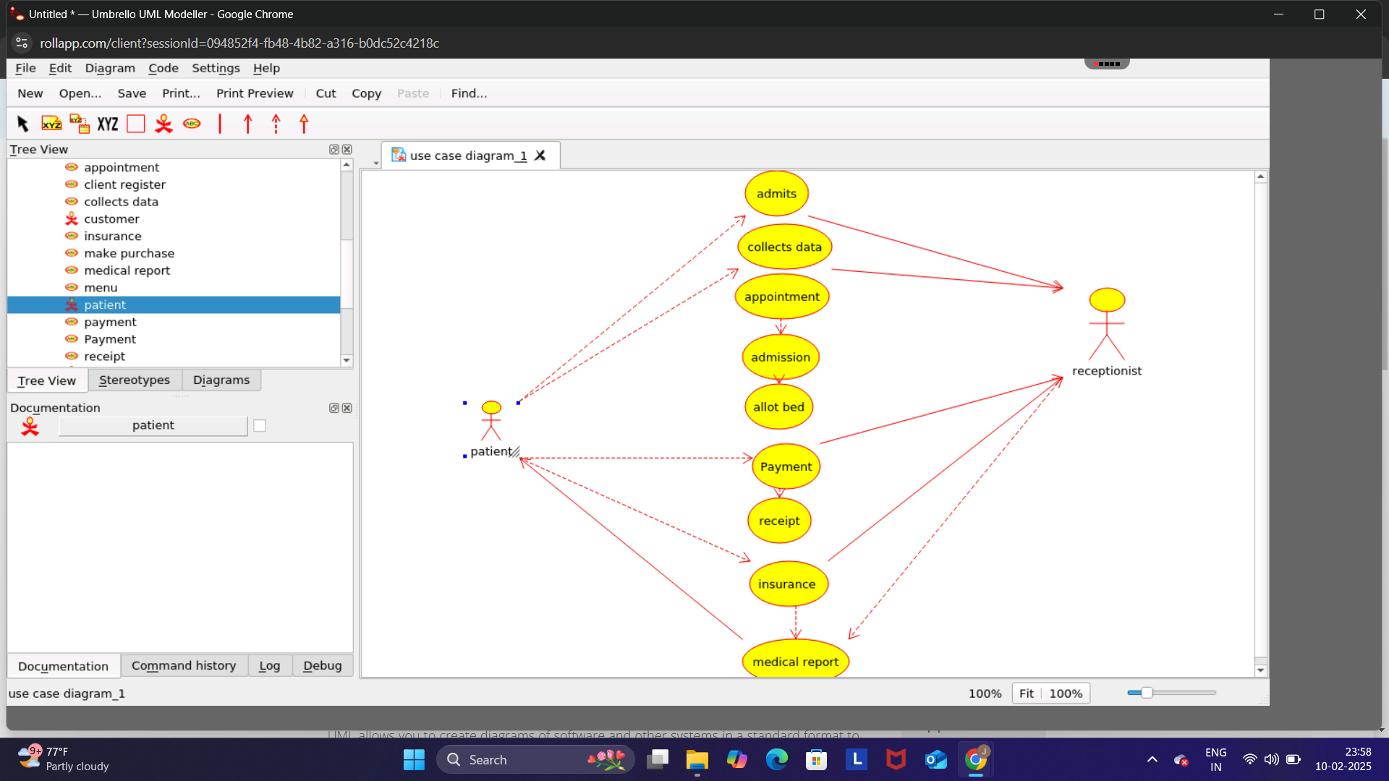

RESULT:

The hospital reception system streamlines administrative tasks and enhances patient experience by managing appointments, payments, and medical records efficiently.

